Write a C++ program that will convert a user input decimal (base 10) integer number in the range 0 to 65535 to hexadecimal (base 16) and a 4 digit hexadecimal number to decimal. The hexadecimal number shall be a 4 character string type data.
Write a structured program that uses separate functions for each operation. Include functions to verify that the user input decimal and hexadecimal numbers are valid.
Write the program to present options to the user as a menu and perform the following operations:

1. Enter Decimal Number.
2. Enter Hexadecimal Number.
3. End

Document the programs with:

A. A written description of the program describing the purpose of the program and the structure of the program.
This program allows users to convert a decimal number (0–65535) to a 4-digit hexadecimal string and vice versa. It uses input validation functions to ensure the decimal and hexadecimal values entered by the user are within valid ranges. The program is structured using separate functions for conversion and validation, and it features a simple menu-driven interface that loops until the user chooses to exit.

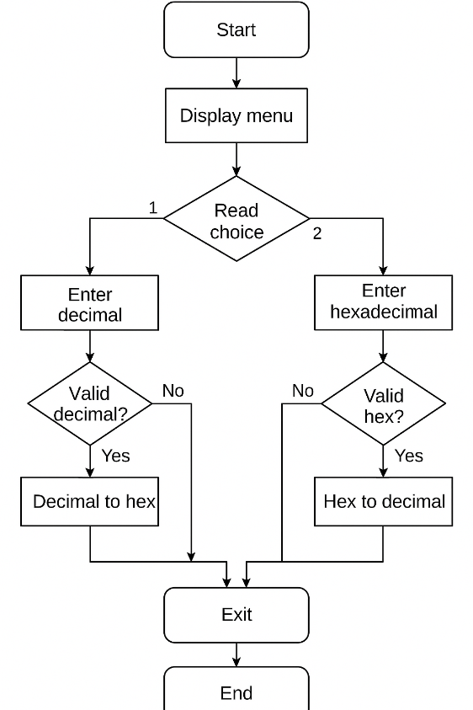
B. A flowchart that illustrates the structure of the program.

C. The code listing.

//ECE 2305 - Programming Project 06

#include <iostream>
#include <string>
#include <iomanip>
#include <sstream>

using namespace std;

string decimalToHex(int num) {
stringstream ss;
ss << uppercase << setfill('0') << setw(4) << hex << num;
return ss.str();
}

int hexToDecimal(const string& hex) {
return stoi(hex, nullptr, 16);
}

bool isValidHex(const string& hex) {
if (hex.length() != 4) return false;
for (char c : hex) {
if (!isxdigit(c)) return false;
}
return true;
}

int main() {
int choice;
while (true) {
cout << "\nMenu:\n1. Enter Decimal Number\n2. Enter Hexadecimal Number\n3. End\nChoice: ";
cin >> choice;
if (choice == 3) break;

switch (choice) {
case 1: {
int num;
cout << "Enter decimal (0-65535): ";
cin >> num;
if (num >= 0 && num <= 65535)
cout << "Hexadecimal: " << decimalToHex(num) << "\n";
else
cout << "Invalid decimal number.\n";
break;
}
case 2: {
string hex;
cout << "Enter 4-digit hexadecimal: ";
cin >> hex;
if (isValidHex(hex))
cout << "Decimal: " << hexToDecimal(hex) << "\n";
else
cout << "Invalid hexadecimal number.\n";
break;
}
default:
cout << "Invalid choice.\n";
}
system("pause");
}
system("pause");
return 0;
}

D. Screen shots showing the program in operation.

